**ASSIGNMENT (POSITIONS IN CSS)**

**Task 1: Problem Statement**

Write code to position 5 equal-sized(50 X 50px) boxes A,B,C,D and E as follows,

**Box A -** 200px from left and -30px from the top of the viewpoint.

**Box B -** -30px left and -30px above from the center of box A.

**Box C -** -30px right and -30px above from the center of box A.

**Box D -** -30px left and -30px below from the center of box A.

**Box E -** -30px right and -30px below from the center of box A.

**Expected Output**

**Solution:-** 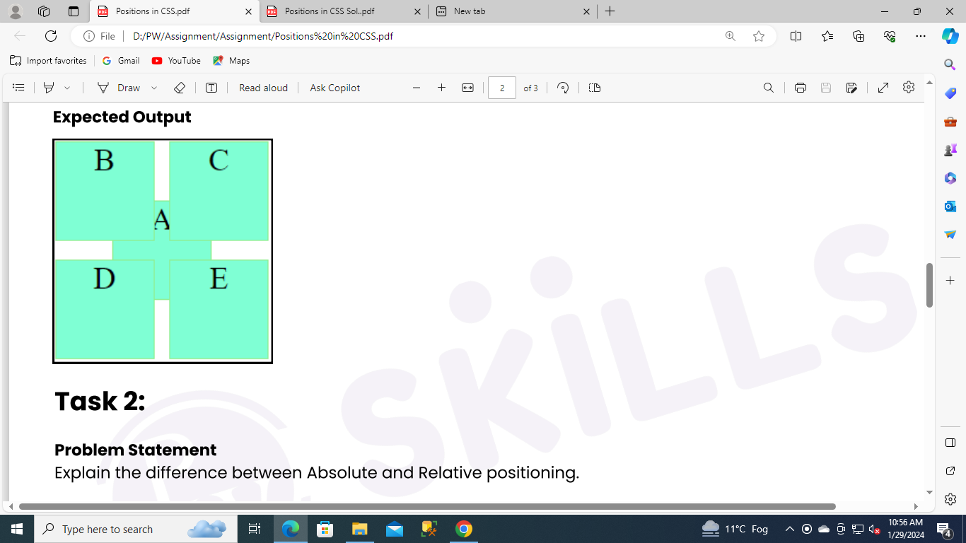

Index.html

<!DOCTYPE html>

<html lang="en">

<head>

<meta charset="UTF-8" />

<meta name="viewport" content="width=device-width, initial-scale=1.0" />

<link rel="stylesheet" href="index.css" />

<title>Document</title>

<link rel="stylesheet" href="style.css">

</head>

<body>

<div class="box boxA">A

<div class="box boxB">B</div>

<div class="box boxC">C</div>

<div class="box boxD">D</div>

<div class="box boxE">E</div>

</div>

</body>

</html>

Style.css

.box {

width: 50px;

height: 50px;

background-color: aquamarine;

border: 1px solid lightgreen;

text-align: center;

}

.boxA {

position: relative;

top: 200px;

left: 200px;

}

.boxB {

position: absolute;

left: -30px;

bottom: 30px;

}

.boxC {

position: absolute;

right: -30px;

bottom: 30px;

}

.boxD {

position: absolute;

left: -30px;

top: 30px;

}

.boxE {

position: absolute;

right: -30px;

top: 30px;

}

**OUTPUT:-**

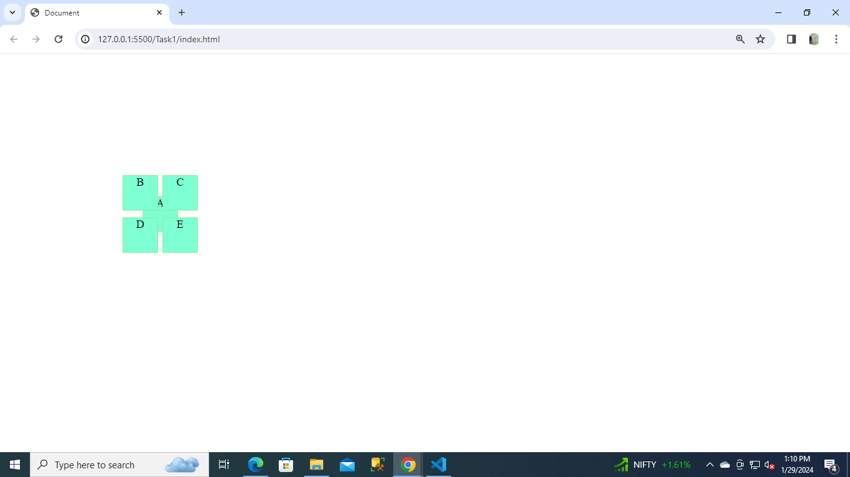

**Task 2: Problem Statement**

Explain the difference between Absolute and Relative positioning.

**Solution:-**

| Absolute | Relative |
| --- | --- |
| **Syntax:-**  {  position: absolute;  } | **Syntax:-**  {  position: relative;  } |
| Setting the top, right, bottom, and left properties of an element with *position: relative;* property will cause it to adjust from its normal position. The other objects or elements will not fill the gap. | An element with *position: absolute;* will cause it to adjust its position with respect to its parent. If no parent is present, then it uses the document body as parent. |
| It will not break the normal document flow to position the element on the page. | It will break the normal document flow to position the element on the page. |
| The element will leave the space at its original position & other content will not be adjusted to fit into any left by the element. | The element will not leave any space in its original position. |

**Task 3: Problem Statement**

Create a card as shown in the picture below.(You can use CSS float property only for layout).

**Expected Output**

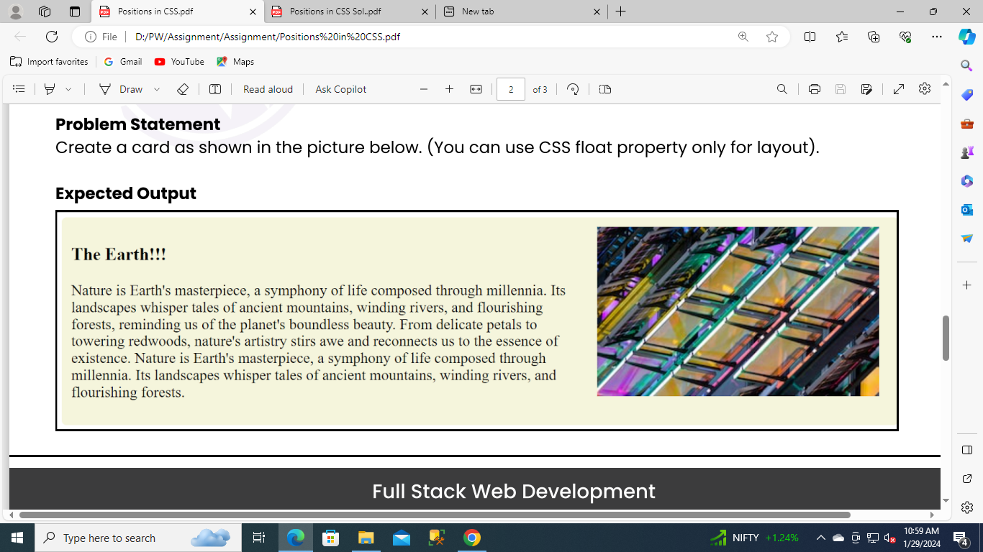

**Solution:-**

index.html

**<!DOCTYPE html>**

**<html lang="en">**

**<head>**

**<meta charset="UTF-8" />**

**<meta name="viewport" content="width=device-width, initial-scale=1.0" />**

**<title>Document</title>**

**<link rel="stylesheet" href="style.css" />**

**</head>**

**<body>**

**<div class="card">**

**<img class="card-image" src="https://random.imagecdn.app/300/180" alt="random image" />**

**<div class="card-body">**

**<h3 class="card-title">The Earth!!!</h3>**

**<p>**

**Nature is Earth's masterpiece, a symphony of life composed through millennia. Its landscapes whisper**

**tales of ancient mountains, winding rivers, and flourishing forests, reminding us of the planet's**

**boundless beauty. From delicate petals to towering redwoods, nature's artistry stirs awe and reconnects**

**us to the essence of existence.Nature is Earth's masterpiece, a symphony of life composed through**

**millennia. Its landscapes whisper tales of ancient mountains, winding rivers, and flourishing forests.**

**</p>**

**</div>**

**</div>**

**</body>**

**</html>**

Style.css

.card {

padding: 10px;

background-color: beige;

border-radius: 5px;

height: 180px;

}

.card-image {

float: right;

padding-left: 10px;

padding-right: 10px;

}

.card-body{

display: grid;

}

**OUTPUT:-**

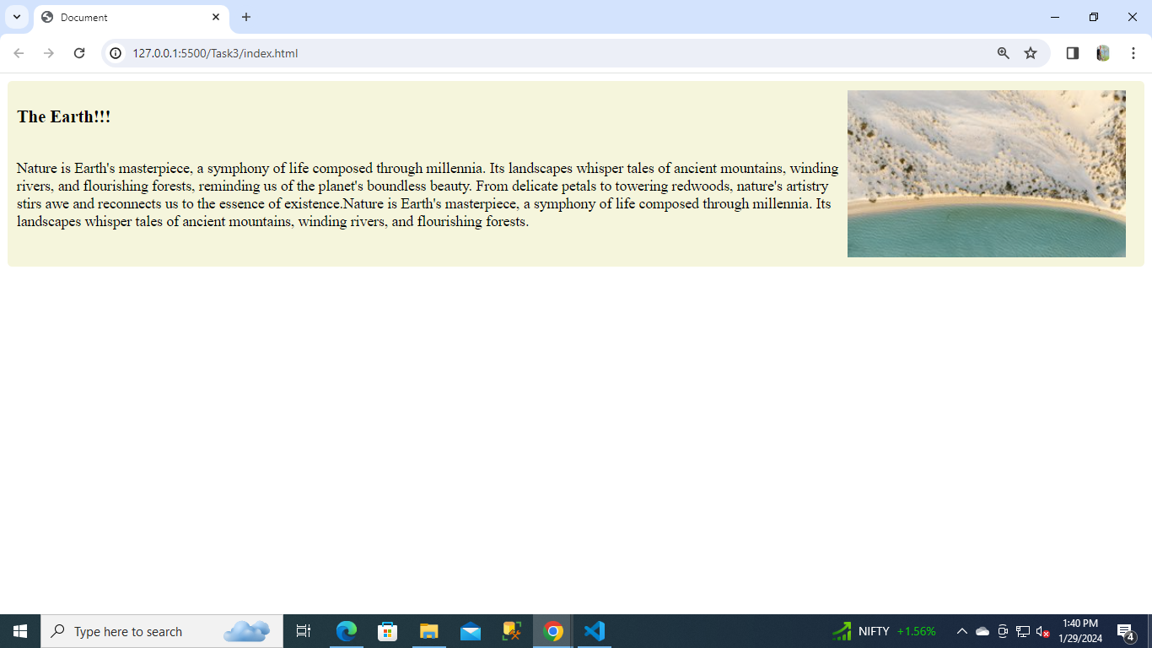

**Task 4: Problem Statement**

Create a simple header that sticks to the top of a webpage upon scrolling.

**Expected Output**

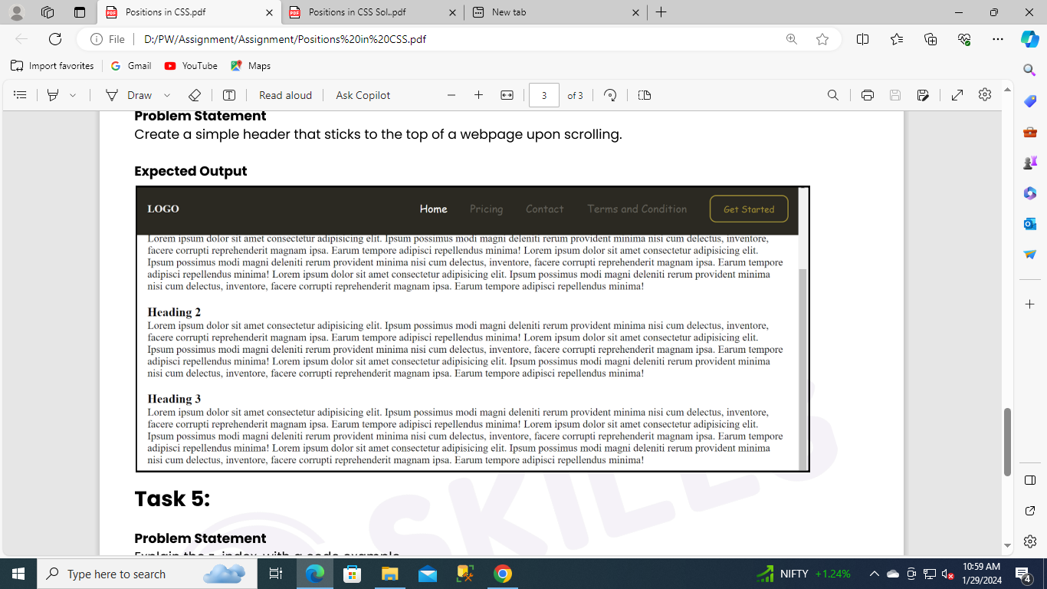

**Solution:-**

Index.html

<!DOCTYPE html>

<html lang="en">

<head>

<meta charset="UTF-8">

<meta name="viewport" content="width=device-width, initial-scale=1.0">

<title>Document</title>

<link rel="stylesheet" href="style.css" />

</head>

<body>

<div class="main">

<header class="header">

<div class="logo">LOGO</div>

<div class="nav">

<ul>

<li class="nav-item active">Home</li>

<li class="nav-item">Pricing</li>

<li class="nav-item">Contact</li>

<li class="nav-item">Terms and Condition</li>

<li class="nav-item button"><button>Get Started</button></li>

</ul>

</div>

</header>

<main>

<section>

<h3>Heading 1</h3>

<p>

Lorem ipsum dolor sit amet consectetur adipisicing elit. Nobis esse dolore aperiam architecto quos qui pariatur incidunt, hic, eos, quam in? Corporis voluptates asperiores commodi atque reprehenderit tenetur obcaecati ab itaque earum. Magni maxime dolorem, corporis sunt eius eveniet commodi.

</p>

</section>

<section>

<h3>Heading 2</h3>

<p>

Lorem ipsum dolor sit amet consectetur adipisicing elit. Quo nostrum adipisci atque laudantium suscipit debitis repudiandae deserunt facere maxime beatae! Lorem, ipsum dolor sit amet consectetur adipisicing elit. Inventore dolor facere, modi fugit ab aliquam magni veritatis adipisci velit explicabo.

</p>

</section>

<section>

<h3>Heading 3</h3>

<p>

Lorem ipsum dolor sit amet consectetur adipisicing elit. Cupiditate fugit rem possimus impedit quod libero tempora labore vitae atque reprehenderit, iure molestiae quis facilis aliquam consectetur vel similique expedita accusantium esse error sequi eius eveniet?Lorem ipsum dolor sit amet consectetur adipisicing elit. Ipsum ad minima modi tenetur obcaecati dignissimos adipisci consectetur totam facilis quam.

</p>

</section>

</main>

</div>

</body>

</html>

Style.css

* {

padding: 0px;

margin: 0px;

}

.header {

position: sticky;

top: 0px;

height: 80px;

color: #f0efee;

background-color: #2b2922;

}

.logo {

position: absolute;

top: 0px;

bottom: 0px;

left: 20px;

margin: auto 0px;

height: fit-content;

font-weight: bold;

}

.logo img {

width: 120px;

}

.nav {

position: absolute;

top: 0px;

bottom: 0px;

right: 0px;

margin: auto 0px;

height: fit-content;

font-family: "Red Rose", cursive;

}

.nav-item {

display: inline;

margin: 0px 15px;

color: #63615a;

}

.nav-item.active {

color: #ffffff;

}

.nav-item.button>button {

padding: 10px 20px;

background: transparent;

border: 2px solid #a08f36;

border-radius: 10px;

color: #a08f36;

font-family: "Red Rose", cursive;

}

main {

padding: 20px;

}

section {

margin-top: 20px;

}

**OUTPUT:-**

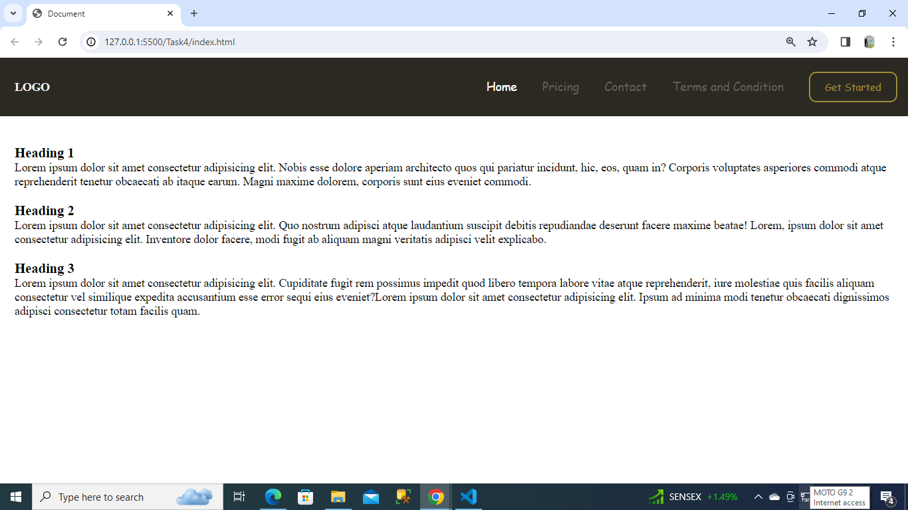

**Task 5: Problem Statement**

Explain the z-index, with a code example.

**Solution:-** Z-index is the CSS property that controls the stacking order of overlapping elements on a page. An element with a higher z-index value will appear in front of an element with a lower z-index value**.**

It determines the order in which elements are stacked on top of each other along the z-axis, creating a 3D-like effect even though web pages are inherently 2D.

z-index only works on positioned elements (position: absolute, position: relative, position: fixed, or position: sticky) and flex items (elements that are direct children of display:flex elements).

**Example:-**

Index.html

<!DOCTYPE html>

<html>

<head>

<meta charset="UTF-8">

<meta name="viewport" content="width=device-width, initial-scale=1.0">

<title>Document</title>

<link rel="stylesheet" href="style.css" />

</head>

<body>

<h1>Z-index Example</h1>

<p>An element with greater stack order is always above an element with a lower stack order.</p>

<div class="container">

<div class="box-1">Black box (z-index: 1)</div>

<div class="box-2">Gray box (z-index: 3)</div>

<div class="box-3">Green box (z-index: 2)</div>

</div>

</body>

</html>

Style.css

.container {

position: relative;

}

.box-1 {

position: relative;

z-index: 1;

background: red;

border: 2px solid black;

width: 40%;

height: 100px;

margin: 30px;

}

.box-2 {

position: absolute;

z-index: 3;

background: lightgray;

border: 2px solid black;

height: 100px;

width: 70%;

left: 100px;

top: 70px;

}

.box-3 {

position: absolute;

z-index: 2;

background: lightgreen;

border: 2px solid black;

width: 35%;

left: 270px;

top: -15px;

height: 100px;

}

**OUTPUT:-**

